Producer – the program/logic that puts data into kafka
Here our python logic that contains –
Connects with coinbase
Subscribe
Receive msg
Validate data
Add metadata
Choose kafka topic/key
Put
Handle failure

Kafka Cluster – Group of Brokers
Broker – Actual Server that stores and publish data
Topic- Logical Dividation
Partition - unit of ordering and parallelism. – (e.g. BTC-USD, ETH – USD, SOL – USD)
Replication = copies of partition across brokers for fault tolerance.
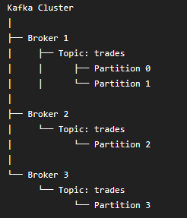

In our project we have 3 brokers, with 3 partitions with 3 replication
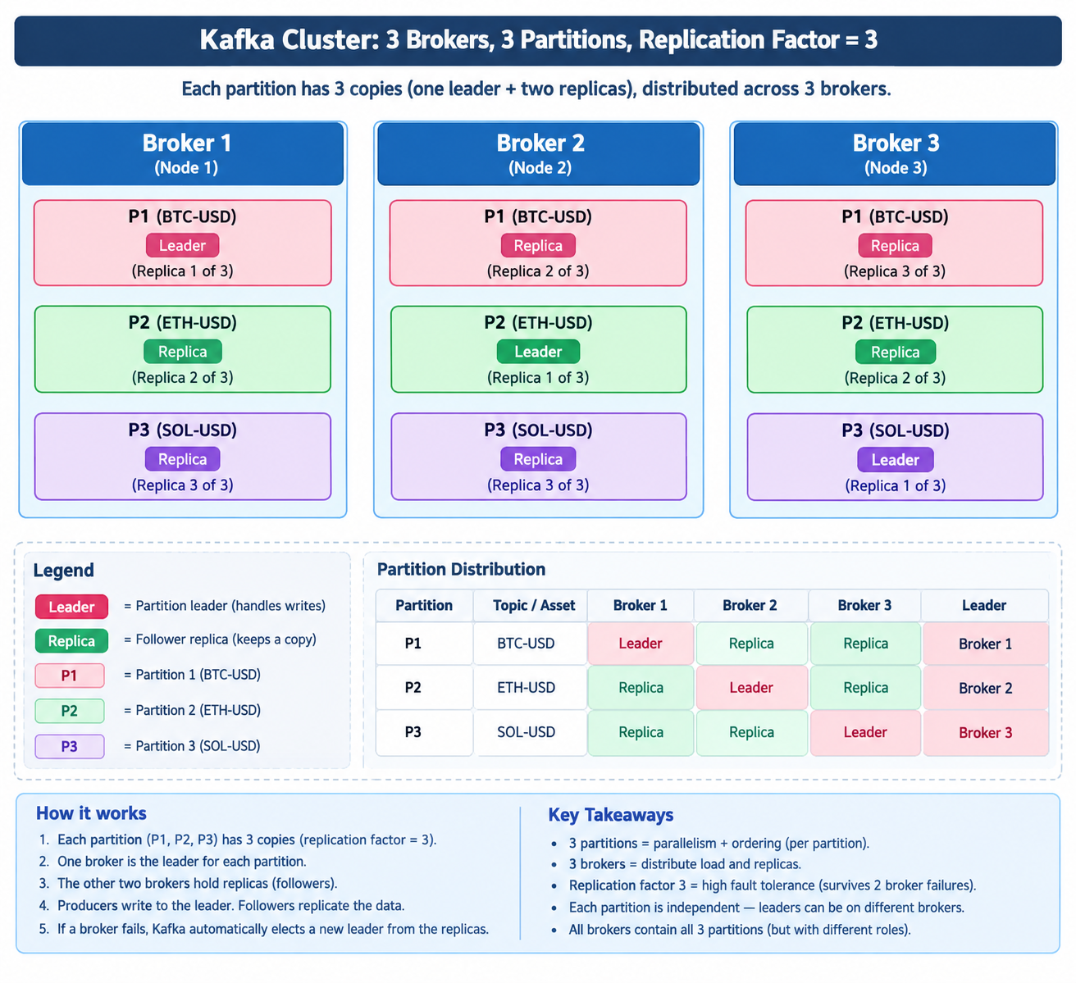
Bootstrap server in docker compose file - the entry-point address your producer uses to make its very first network connection to the Kafka cluster.

Kafka Producer Logic
Data flow into Kafka:
Coinbase WebSocket
│
│ one listener per product
│ BTC-USD / ETH-USD / SOL-USD
▼
Python ingestion process
│
│ Kafka producer
│ key = configured product ID
│ value = untouched raw Coinbase JSON batch
│ headers = source, connection_product_id, ingestion_version
▼
Kafka topic: coinbase.raw.trade_batches
│
├── Partition 0
├── Partition 1
└── Partition 2
How records are partitioned:
- The producer sends BTC-USD, ETH-USD, or SOL-USD as the Kafka message key.
- Kafka hashes that key and selects one of the three partitions.
- The same key consistently goes to the same partition, as long as we do not change the partition count.
- Therefore, trade-batch order is preserved within each product’s partition.
- We do not manually send records to Kafka broker 1, 2, or 3. Kafka handles that.
Example mapping only—your actual mapping may differ:
ETH-USD key → Partition 0
BTC-USD key → Partition 2
SOL-USD key → Partition 1
For each partition:
Producer → partition leader broker → replicated to the other two brokers
With replication factor 3, every record is stored on all three brokers:
Partition 0:
leader: one broker
replicas: Kafka 1, Kafka 2, Kafka 3

Partition 1:
leader: one broker
replicas: Kafka 1, Kafka 2, Kafka 3

Partition 2:
leader: one broker
replicas: Kafka 1, Kafka 2, Kafka 3
The producer waits for replicated acknowledgement (acks=all), so Kafka confirms a batch only after the leader and in-sync replicas acknowledge it.

Spark Transformation Logic
• Read coinbase.raw.trade_batches from Kafka.
• Parse the raw JSON.
• Separate events[].trades[] so one Kafka output record represents one trade.
• Validate required fields and data types.
• Convert price and size into precise decimal values and parse trade time.
• Add useful derived fields such as notional_usd = price × size.
• Deduplicate using product_id + trade_id.
• Publish valid trades to a new Kafka topic: coinbase.curated.trades.
• Send malformed/unusable messages to a separate invalid-data topic for investigation.

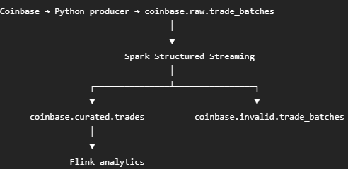

This transformation will curate and create fields mentioned below for each record:
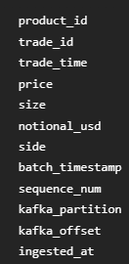
• Spark curation makes the clean trade-level data.
• Flink will calculate live metrics from that data: OHLC, VWAP, rolling volume, price changes, volatility, and activity alerts.
• MySQL and Grafana will make those calculated metrics visible.
Business objectives achieved after this transformation step:
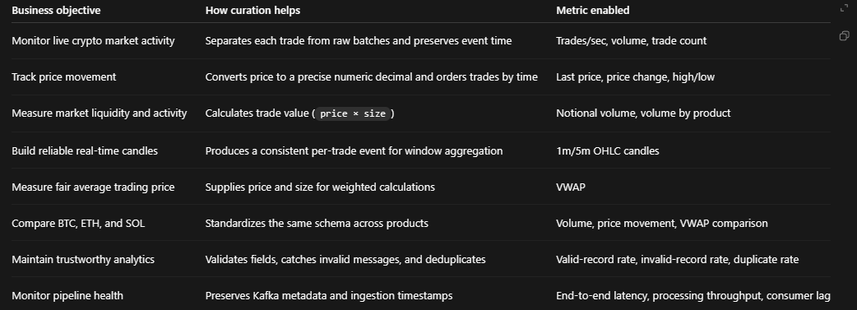

Spark Pipeline will do:
• Add pipelines/spark/trade_curator.py
- Read coinbase.raw.trade_batches.
- Parse raw Coinbase JSON without changing the original source topic.
- Flatten every nested trade into one row.
- Validate product_id, trade_id, price, size, and trade time.
- Cast price/size to decimals, calculate notional_usd, add Kafka provenance fields.
- Deduplicate by product_id + trade_id.
- Write valid records to coinbase.curated.trades.
- Write invalid records to coinbase.invalid.trade_batches.
• Update Kafka topic initialization to create those two topics
With
coinbase.curated.trades. - three partitions and 3 replication factor
and coinbase.invalid.trade_batches. - two partitions and 2 replication

We have one spark woker - coinbase-spark-worker-1 means this is our first Spark worker. It is deliberate, so later we can add:
coinbase-spark-worker-2
coinbase-spark-worker-
That is how Spark processing capacity scales. We currently use one worker with 2 CPU cores and 2 GB memory, which is enough for this local project stage.
Defined in infra/docker/docker-compose.spark.yml
environment:
SPARK_WORKER_CORES: "2"
SPARK_WORKER_MEMORY: "2g"

This is how our Curated data are looks like in kafka topic

[
{
"partition": 2,
"offset": 628,
"symbol": "ETH-USD",
"payload": {
"product_id": "ETH-USD",
"trade_id": "842252359",
"trade_time": "2026-09-12T01:38:45.158Z",
"price": 2512.41,
"size": 0.94882697,
"notional_usd": 2383.8423677,
"side": "BUY",
"batch_timestamp": "2026-09-12T01:38:45.217038898Z",
"sequence_num": 5,
"event_type": "update",
"kafka_topic": "coinbase.raw.trade_batches",
"kafka_partition": 0,
"kafka_offset": 49,
"kafka_received_at": "2026-09-12T01:38:45.193Z",
"curated_at": "2026-09-12T01:38:50.005Z"
}
},
{
"partition": 2,
"offset": 629,
"symbol": "ETH-USD",
"payload": {
"product_id": "ETH-USD",
"trade_id": "842252326",
"trade_time": "2026-09-12T01:38:29.717Z",
"price": 2513.2,
"size": 0.001,
"notional_usd": 2.5132,
"side": "BUY",
"batch_timestamp": "2026-09-12T01:38:43.190188474Z",
"sequence_num": 0,
"event_type": "snapshot",
"kafka_topic": "coinbase.raw.trade_batches",
"kafka_partition": 0,
"kafka_offset": 48,
"kafka_received_at": "2026-09-12T01:38:43.167Z",
"curated_at": "2026-09-12T01:38:50.005Z"
}
},
{
"partition": 2,
"offset": 630,
"symbol": "ETH-USD",
"payload": {
"product_id": "ETH-USD",
"trade_id": "842252368",
"trade_time": "2026-09-12T01:38:49.738Z",
"price": 2512.16,
"size": 0.0421869,
"notional_usd": 105.9802427,
"side": "BUY",
"batch_timestamp": "2026-09-12T01:38:49.81632309Z",
"sequence_num": 12,
"event_type": "update",
"kafka_topic": "coinbase.raw.trade_batches",
"kafka_partition": 0,
"kafka_offset": 51,
"kafka_received_at": "2026-09-12T01:38:49.793Z",
"curated_at": "2026-09-12T01:38:50.005Z"
}
}
]

Few things to notice:
That is a successful end-to-end result: Coinbase → producer → raw Kafka → Spark curator → curated Kafka.
A few useful observations:
- partition: 2, offset: 628 is the record’s location in the curated topic.
- kafka_partition: 0, kafka_offset: 49 identifies the original raw Kafka batch Spark read.
- notional_usd is correct: 2512.41 × 0.94882697 = 2383.8423677.
- curated_at is about 5 seconds after kafka_received_at, which is normal because Spark runs in 10-second micro-batches.
- symbol: ETH-USD is your consumer display’s representation of the Kafka message key.
- event_type: snapshot is an initial Coinbase snapshot batch. We keep it, identify it clearly, and deduplicate with product_id + trade_id.
One important point: Kafka output order is not the same as strict trade-time order. For example, offset 629 has an earlier trade_time than offset 628. That can happen because Coinbase snapshots include recent earlier trades and Spark processes a micro-batch as a group. Later, Flink will use trade_time and watermarks—not Kafka offset order—to calculate accurate time-window analytics.

Small note for our spark architecture:
Spark Ordering and Latency Notes

- Kafka preserves record order only within the same partition. Spark reads records in micro-batches and may reorder them during flattening, deduplication, parallel processing, and writing to the curated Kafka topic.

- Therefore, curated Kafka offsets do not represent exact financial trade-time order. For analytics, use trade_time as the source of truth. Kafka partition/offset, batch_timestamp, and sequence_num are retained for tracing and debugging.

- Coinbase may send snapshot events containing trades older than newly received update events. This is expected and is handled through product_id + trade_id deduplication.

- Our Spark job currently runs every 10 seconds. A record can wait 0–10 seconds before transformation, with an average delay of about 5 seconds. This is an intentional tradeoff between lower resource use and near-real-time dashboard updates.

- Later, the trigger can be reduced to 1 second if lower latency is needed, but this increases CPU and processing overhead.

Flink Part
Supporting links:
Example OHLC Candle Dashboard - https://www.amcharts.com/demos/live-stock-data/
Pattern in OHLC Candles - https://questdb.com/glossary/ohlc-candlestick/
Which can be identified by AI.

Following is calculated by Flink for 1 min time window:
OHLC prices
VWAP
trade count
base volume
USD notional volume

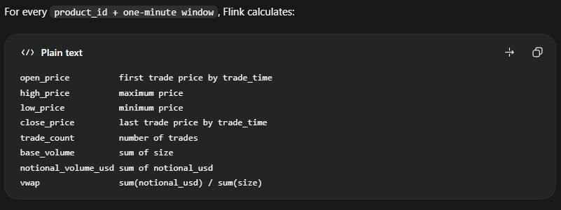

Our Watermark – Allowing 30 seconds out-of-order arrival
trade_time will be used for 1 min window calculations – not kafka or system time

Use this Table to understand watermark concept and data arrival concept:
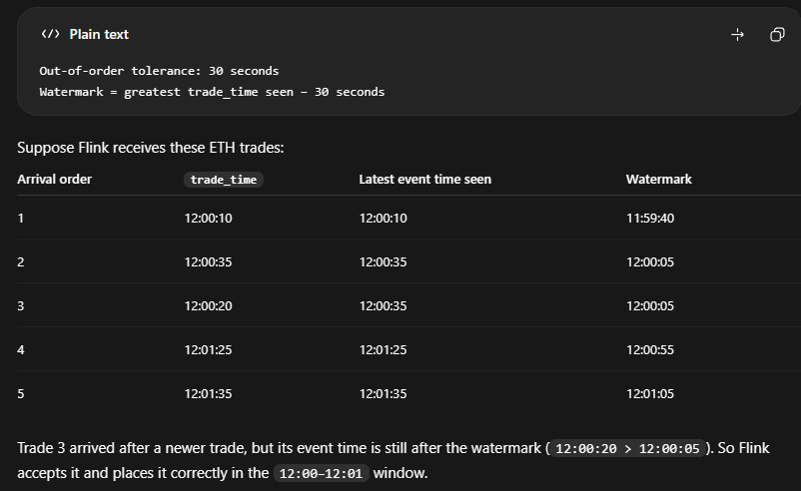

My Understanding:
Okay - I understood this from my intutuion
1 - It is possible that two windows remains open
Because we are giving offset of 30 seconds to arrive the data which might belongs to the previous window.
2 - Window Already decided on the tread time, whatever the water mark is there
e.g. Incoming trade: 12:00:02
Window: [12:00:00, 12:01:00) - will eventually lends here.
e.g. Incoming trade: 12:01:02
Window: [12:01:00, 12:02:00) - will eventually lends here.
3 - The watermark just decides when to close the window -
Here when to from [12:00:00, 12:01:00) -> [12:00:00, 12:01:00] <- Close the window - when watermark becomes >12:01:00 close the window.
so it only decides when to close the window and not which record will lend in which window or anything.
2 - If tread_time leap between 2 consecutive records are large then the previous window will shut early - because that watermark after substracting 30 from the trade time also comes closer to 12:00:59.99 very fast.
3 - if trade_time leap between 2 consecutive records are small (for e.g. 1-1 second) then the previous window stays open for longer period of time - because watermark comes closer to 12:00:59.99 very slow (after roughly 1 -1 second). Allows more time to the older records which belongs might belongs to the previous window.

Curated that perfect understanding with AI:
Your intuition is right. A few precise refinements:
- Yes—multiple windows can be open at the same time.
With one-minute windows and a 30-second watermark delay, it is common for the current minute and previous minute to both remain open.
Current event time around 12:01:20
Watermark around 12:00:50

Open windows:
[12:00:00, 12:01:00)
[12:01:00, 12:02:00)
In unusual cases—slow partitions, idle-input handling, or a larger watermark delay—more than two windows may remain open.
- Correct: trade_time selects the window.
12:00:02 → [12:00:00, 12:01:00)
12:01:02 → [12:01:00, 12:02:00)
Watermark never moves a trade into another minute. The only exception is a trade that arrives after its original window has been cleaned up; then Flink sends it to the late-events path rather than changing its bucket.
- Correct: watermark controls finalization.
Use an end-exclusive window notation:
[12:00:00, 12:01:00)
The 12:00 window closes when:
watermark >= 12:01:00
It then has its final normal result emitted and its state can later be removed.
- Correct: a large event-time jump advances the watermark quickly.
Example:
Previous maximum trade_time: 12:00:20
New incoming trade_time: 12:05:00
New watermark: 12:04:30
That closes the 12:00, 12:01, 12:02, and 12:03 windows quickly.
It is not “early” in event-time terms—the watermark says the source has progressed far beyond them. But it can be early in wall-clock terms if old data arrives unusually late afterward. That is why we retain a late-events path and may configure allowedLateness.
- Correct: small event-time increments make watermark progress slowly.
If trade times progress second by second, the watermark also progresses second by second. The prior window stays open until the watermark reaches its end.
trade_time: 12:01:20
watermark: 12:00:50
→ 12:00 window remains open

trade_time: 12:01:30
watermark: 12:01:00
→ 12:00 window can close
So yes: slower watermark progress gives delayed older records more real arrival-time opportunity to reach their correct previous window.

Flink Implementation logic:
At the time of implementation stage we have:
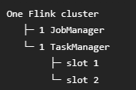
Later we will add more Job manager.
With this we have 2 parallelism
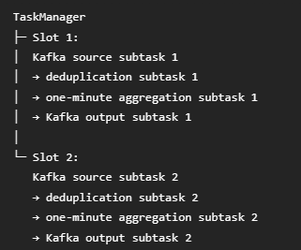
Our Flink Job:
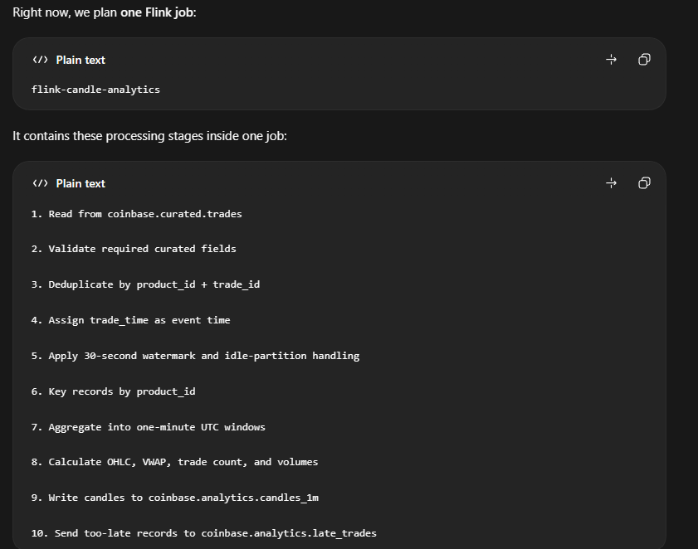
Summary:
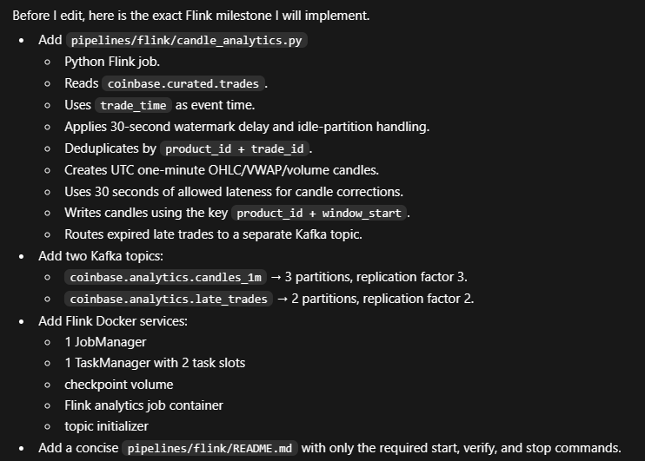

Flink 1 Min Candle output:
